Name______Michael King____ Mark _____________________/50

[**Instructions**: Remove everything that is not a heading below and fill in with your own diagrams, etc.]

## Brief introduction __/3

My feature for The Crawl videogame is the start menu and the Resource bar HUD/Inventory system HUD. When the game begins the player interacts with the start menu to choose between options such as playing Checking the Controls and exiting the game. The UI then provides the player with an hp/resource bar depending on class and a display of the inventory system that contains three empty slots for items. During gameplay the UI allows the player to inventory slots so the player can use items efficiently. This feature is important because it will directly affect the player’s strategy and resource management.

## Use case diagram with scenario __14

Doing the Case diagram for the Resource bar HUD/Inventory system HUD as the start menu will be Just three choices and very simple.

### Use Case Diagrams

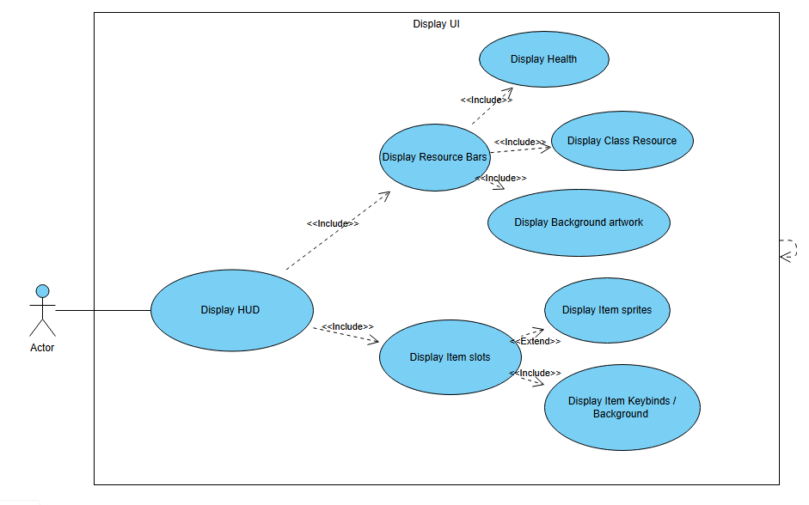

### Scenarios

**[You will need a scenario for each use case]**

**Summary:** Show the in-game heads-up display (HUD) so the player can monitor health, resources, and inventory information during gameplay.

**Actor:** Player

**Preconditions:** The game is running

**Basic Flow** The player starts a game session.

The system renders the HUD frame.

The system checks player data for changes to hp / resources If there is a change.

**If** there is a change, update it and show animation to the hp bar

The system checks player data to see if there is a change in items.

**IF** there is a change go to item info and display the correct sprite.

**Exceptions  
 Player hp goes negative.**

**Item slots are empty**

**Priority  
 1**

*The priorities are 1 = must have, 2 = essential, 3 = nice to have.

## Data Flow diagram(s) from Level 0 to process description for your feature _______14

[Get the Level 0 from your team. Highlight the path to your feature]

Example:

### Data Flow Diagrams

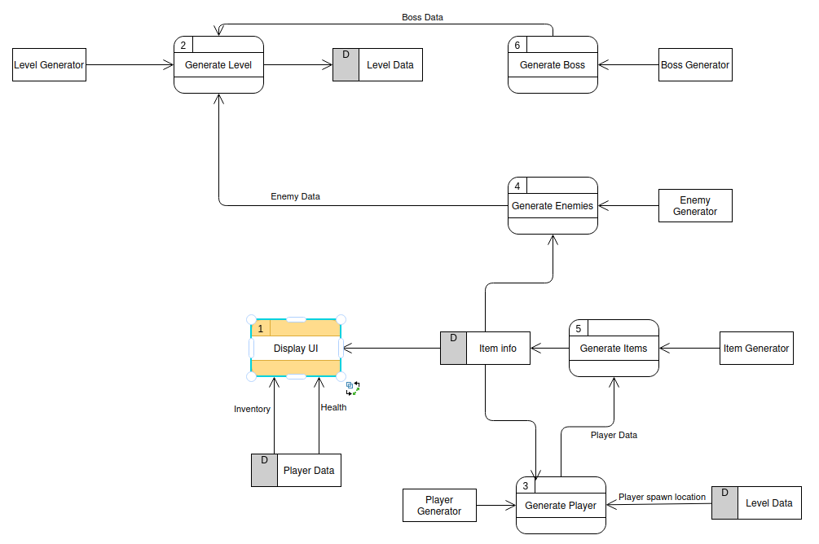

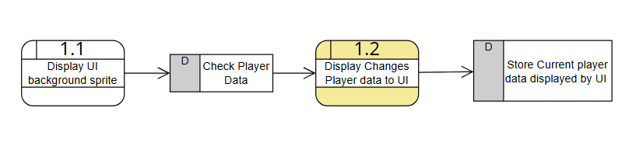

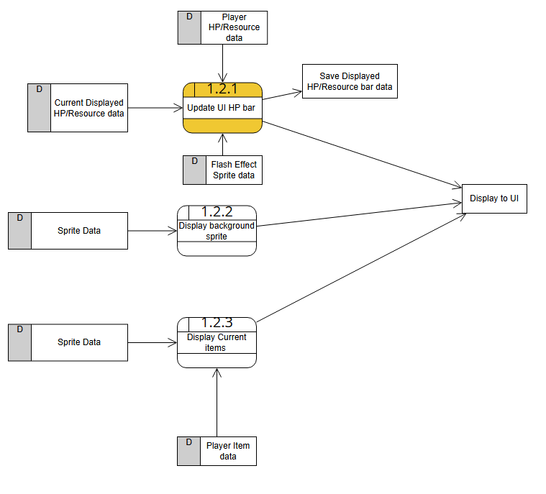

### Process Descriptions

Binds to Update UI HP Bar*:

INPUT NewHP

FETCH CurrentHP

IF NewHP < CurrentHP THEN

PLAY DamageSound

PLAY HPBarAnimation from CurrentHP to NewHP

ELSE IF NewHP > CurrentHP THEN

PLAY HealSound

PLAY HPBarAnimation from CurrentHP to NewHP

ELSE

EXIT (no changes in HP since last update)

ASSIGN CurrentHP == NewHP

IF CurrentHP/MaxHP < 0.20 THEN

START FlashEffect on HPBar

ELSE

STOP FlashEffect on HPBar.

## Acceptance Tests ________9

**Example for divide feature**

Run feature 10 complete game sessions tracking health changes and item pickups while displaying all updates in the HUD.

Across the 10 playthroughs the player begins each game with full health and no items equipped.  
The player’s new picked up a new item are immediately assigned to an available slot in the inventory and its unique sprite.  
 If an item is removed from the inventory it is displayed in the UI.  
 Each time damage occurs the HP bar smoothly animates over 0.5 seconds from the current value to the new value and a damage sound plays.  
 Whenever health falls below twenty percent of the maximum the HP bar begins to blink to warn the player of the critical condition.  
 When a potion is used the HP bar smoothly animates upward over 0.5 seconds to the restored value and a heal sound plays.  
 If the healed amount raises health above twenty percent of the maximum the blinking stops automatically and the bar returns to normal appearance.

Throughout all ten game runs the process repeats: items are displayed with their unique sprites and sounds the HP bar accurately displays.

## Timeline _________/10

Example:

### Work items

| Task | Duration (PWks) | Predecessor Task(s) |
| --- | --- | --- |
| 1. Start Menu | 5 | - |
| 2. Start Menu Artwork (control / main menu) | 5 | 1 |
| 3. Health / Resource bar HUD | 10 | 1,2 |
| 4. Health / Resource bar artwork | 3 | 1,2,3 |
| 5. Inventory HUD | 10 | 1,2 |
| 6. Sound (Low hp sound no item in slot) | 5 | 1,2,3,4,5 |
| 7. Animations (hp loss resource loss) | 6 | 1,2,3,4,5 |
| 8.Testing | 7 | 1,2,3,4,5,6,7 |
| 9.installation | 2 | 1,2,3,4,5,6,7,8 |

### Pert diagram

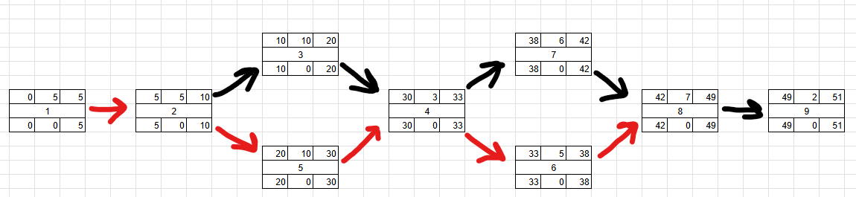

Gnatt

